Design Principles - Reusability
# Source: AI Source: Provided by: [Data Path: Persons Table -> ID Column: 1, Name_En Column: Motasem Essam] -> From: [ChatGPT] on [1/23/2026]
Reusability is the principle of designing components, modules, or services so they can be used in multiple applications or parts of a system without modification.
👉 Think of it like reusable LEGO blocks: the same block can be used in many different builds.

🔑 Key Points
# Source: AI Source: Provided by: [Data Path: Persons Table -> ID Column: 1, Name_En Column: Motasem Essam] -> From: [ChatGPT] on [1/23/2026]
- Avoid duplicating code or functionality
- Design generic, modular components with clear interfaces
- Promotes faster development and consistency
- Often paired with modularity, high cohesion, and loose coupling

❌ Bad Example
# Source: AI Source: Provided by: [Data Path: Persons Table -> ID Column: 1, Name_En Column: Motasem Essam] -> From: [ChatGPT] on [1/23/2026]
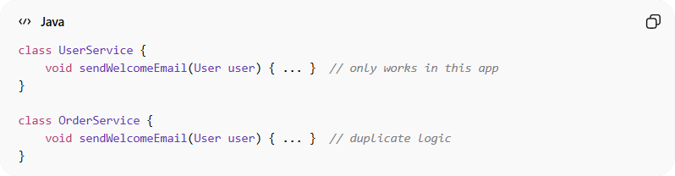
class UserService {
void sendWelcomeEmail(User user) { ... } // only works in this app
}

class OrderService {
void sendWelcomeEmail(User user) { ... } // duplicate logic
}
Problems:
- Email sending logic is duplicated in multiple places
- Hard to maintain or update
- Violates DRY (Don’t Repeat Yourself) principle

✅ Good Example
# Source: AI Source: Provided by: [Data Path: Persons Table -> ID Column: 1, Name_En Column: Motasem Essam] -> From: [ChatGPT] on [1/23/2026]
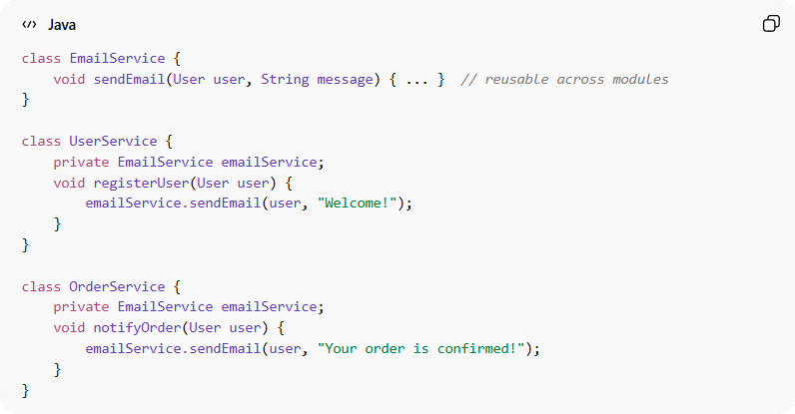
class EmailService {
void sendEmail(User user, String message) { ... } // reusable across modules
}

class UserService {
private EmailService emailService;
void registerUser(User user) {
emailService.sendEmail(user, "Welcome!");
}
}

class OrderService {
private EmailService emailService;
void notifyOrder(User user) {
emailService.sendEmail(user, "Your order is confirmed!");
}
}
Benefits:
- Single component serves multiple parts of the system
- Easier to maintain and extend
- Reduces duplication and errors
- Speeds up development for future projects

⚡ When to Apply
# Source: AI Source: Provided by: [Data Path: Persons Table -> ID Column: 1, Name_En Column: Motasem Essam] -> From: [ChatGPT] on [1/23/2026]
- Libraries, utilities, or services that are common across multiple modules or projects
- Microservices or shared modules in enterprise applications
- Always combine with modularity and abstraction for maximum reusability

